**UNIVERSITY OF ENGINEERING AND TECHNOLOGY, LAHORE**

**(NAROWAL CAMPUS)**

**­**

**NAME :**

**ABDULAHAD HUSSAIN**

**ROLL NO. :**

**549**

**SECTION:**

**A**

**SUBJECT:**

**PROGRAMING FUNDAMENTAL**

**LAB #07:**

**Program No. 1:**

**Statement:**

#include <iostream>

using namespace std;

int main()

{

int x;

for (x =5; x <= 50; x = x+5)

{

// x = x + 5 could also be written x += 5

cout<< "Loop counter value is " << x << ".\n";

}

return 0;

}

Analyze above code and Write output.

**Output:**

Loop counter value is 5

Loop counter value is 10

Loop counter value is 15

Loop counter value is 20

Loop counter value is 25

Loop counter value is 30

Loop counter value is 35

Loop counter value is 40

Loop counter value is 45

Loop counter value is 50

**Flow Chart:**

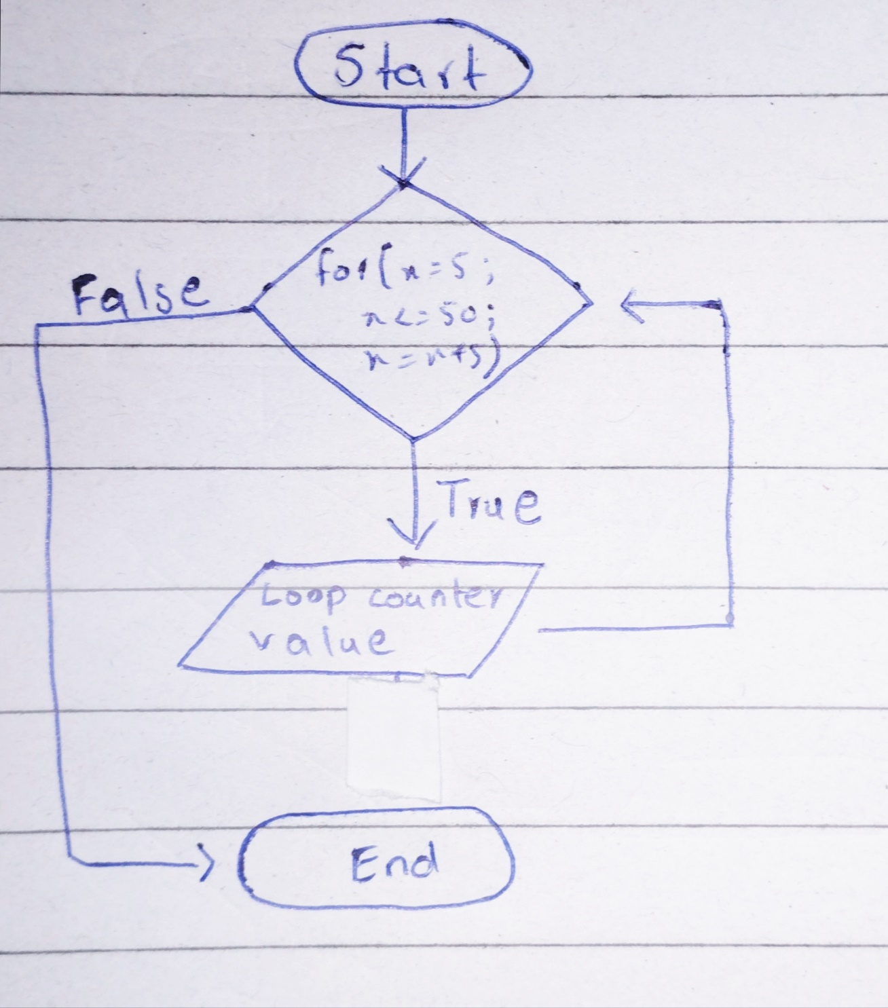

**Program No. 2:**

**Statement:**

Write a program that finds running sum of first 25 natural number.

**Source Code:**

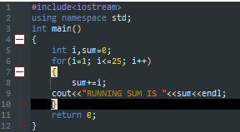

**Output:**

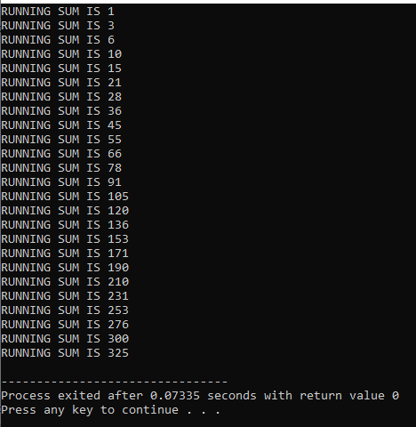

**Flow Chart:**

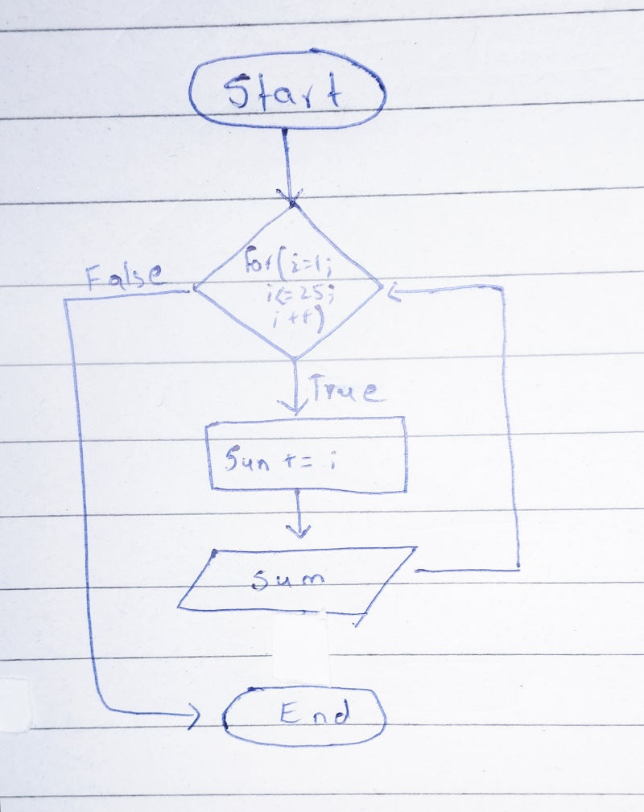

**Program No. 3:**

**Statement:**

Write a program to get an integer from user as input and print its multiplication table.

**Source Code:**

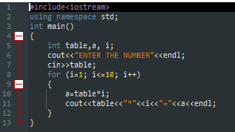

**Output:**

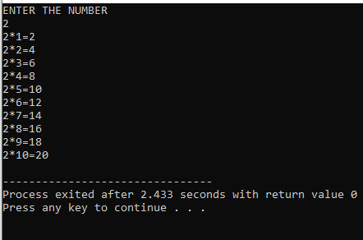

**Flow Chart:**

